1.

<!DOCTYPE html>

<html lang="en">

<head>

<meta charset="UTF-8">

<meta name="viewport" content="width=device-width, initial-scale=1.0">

<style>

body {

font-family: Arial, sans-serif;

margin: 0;

padding: 0;

}

nav {

background-color: #333;

overflow: hidden;

}

nav a {

float: left;

display: block;

color: white;

text-align: center;

padding: 14px 16px;

text-decoration: none;

}

nav a:hover {

background-color: #ddd;

color: black;

}

</style>

</head>

<body>

<nav>

<a href="#home">Home</a>

<a href="#about">About</a>

<a href="#services">Services</a>

<a href="#contact">Contact</a>

<a href="#blog">Blog</a>

</nav>

<!-- Your content goes here -->

</body>

</html>

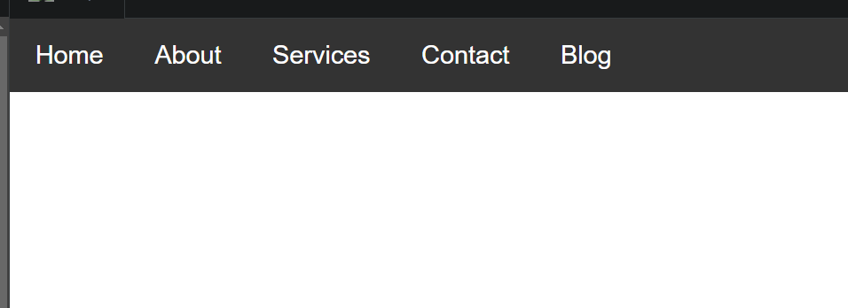

2.

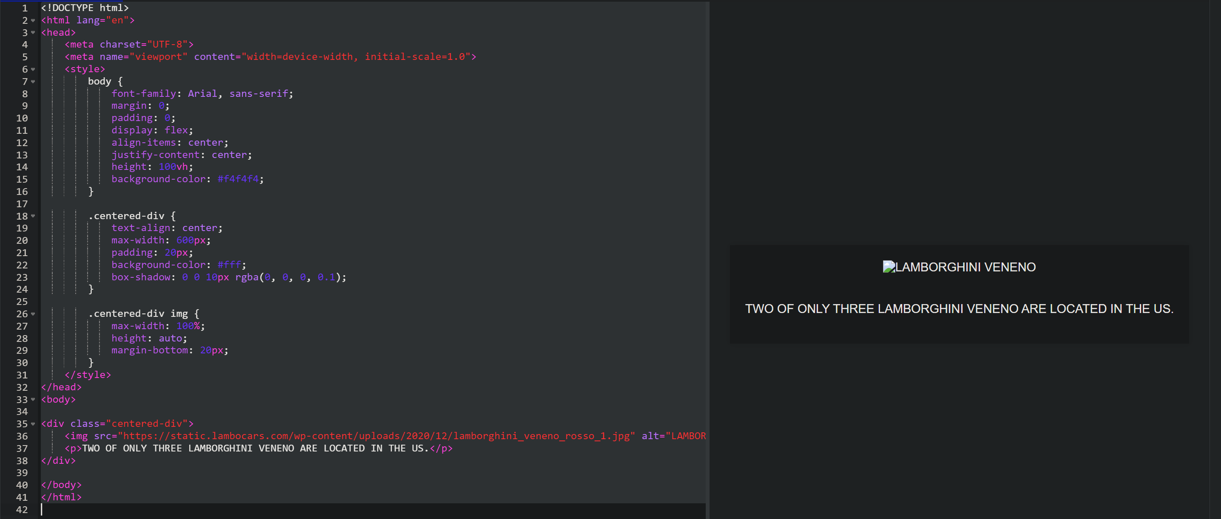

3.

<!DOCTYPE html>

<html lang="en">

<head>

<meta charset="UTF-8">

<meta name="viewport" content="width=device-width, initial-scale=1.0">

<title>Navigation Bar</title>

<link rel="stylesheet" href="style.css">

</head>

<body>

<nav>

<ul>

<li><a href="#">Home</a></li>

<li><a href="#">About</a></li>

<li><a href="#">Services</a></li>

<li><a href="#">Contact</a></li>

<li><a href="#">Blog</a></li>

</ul>

</nav>

</body>

</html>

nav {

background-color: #333; /* Change background color as desired */

display: flex; /* Make the navigation bar horizontal */

justify-content: space-between; /* Distribute links evenly */

padding: 1rem 2rem; /* Add padding for spacing */

}

nav ul {

list-style: none; /* Remove default bullet points */

margin: 0; /* Remove default margin */

padding: 0; /* Remove default padding */

}

nav li {

display: inline-block; /* Display links inline */

margin-right: 1rem; /* Add margin between links */

position: relative; /* Needed for border styling */

}

nav a {

color: #fff; /* Text color */

text-decoration: none; /* Remove underline */

font-weight: bold; /* Make text bold */

padding: 0.5rem 1rem; /* Add padding to links */

}

nav a:hover {

color: #007bff; /* Change text color on hover */

transition: color 0.3s ease-in-out; /* Add smooth transition */

}

/* Different border styles for each link */

nav li:nth-child(1) {

border-bottom: 3px solid #007bff; /* Home - solid blue */

}

nav li:nth-child(2) {

border-right: 3px solid #ff9800; /* About - solid orange */

}

nav li:nth-child(3) {

border-top: 3px solid #28a745; /* Services - solid green */

}

nav li:nth-child(4) {

border-left: 3px solid #dc3545; /* Contact - solid red */

}

nav li:nth-child(5) {

border-radius: 5px; /* Blog - rounded border */

border: 2px solid #fff; /* White border */

}

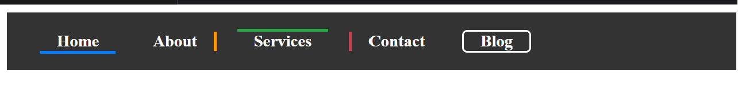

4.

<!DOCTYPE html>

<html lang="en">

<head>

<meta charset="UTF-8">

<meta name="viewport" content="width=device-width, initial-scale=1.0">

<title>Simple Webpage with Circular Image</title>

<style>

body {

font-family: Arial, sans-serif;

margin: 0;

padding: 0;

}

.container {

text-align: center;

margin-top: 50px;

}

.circular-image {

border-radius: 50%;

}

</style>

</head>

<body>

<div class="container">

<img src="https://static.lambocars.com/wp-content/uploads/2020/12/lamborghini_veneno_rosso_1.jpg" alt="LAMBORGHINI VENENO" class="circular-image">

</div>

</body>

</html>

5.

<head>

<meta charset="UTF-8" />

<meta http-equiv="X-UA-Compatible" content="IE=edge" />

<meta name="viewport" content="width=device-width, initial-scale=1.0" />

<title>Google Fonts</title>

<style>

@import url("https://fonts.googleapis.com/css2?

family=Montserrat:wght@300&family=Oswald:wght@500&display=swap");

h1 {

text-align: center;

font-family: "Oswald", sans-serif;

}

img {

width: 450px;

}

p {

font-family: "Montserrat", sans-serif;

}

</style>

</head>

<body>

<h1>Google Fonts</h1>

<img

src="https://www.gstatic.com/images/icons/material/apps/fonts/1x/catalog/v5/opengraph_color.png"

alt="Google Fonts"

/>

<p>

Google Fonts is a library of free and open-source fonts. It allows web designers and developers to choose from a variety of high-quality fonts

to enhance the visual appeal of their websites. One popular font is Montserrat, known for its modern and stylish appearance.

The heading of this page is displayed using the Oswald font, which is also available in the Google Fonts library.

</p>

<p>

Our font catalog places typography front and center, inviting users to

explore, sort, and test fonts for use in more than 135 languages. We

showcase individual type designers and foundries, giving you valuable

information about the typographers and their process, as well as analytics

on usage and demographics. Our series of thematic collections helps you

discover new fonts that have been vetted and organized by our team of

designers, engineers, and collaborators, and our default sort organizes

fonts based on popularity, trends, and your geographic location. You can

also create your own highly customized collections by filtering families,

weights, and scripts, plus test color themes, and review sample copy.

Collections can be shared, making it easy to collaborate on projects and

ensure typography is optimized and streamlined throughout the design and

engineering process. In 2021, we added icons to our Google Fonts catalog,

expanding expressive capability for our users. Our first set was the

Material icons—delightful, beautifully crafted symbols for common

communication needs. Download them on desktop to use them in your digital

products for Android, iOS, and web.

</p>

</body>

6.

<head>

<meta charset="UTF-8" />

<meta http-equiv="X-UA-Compatible" content="IE=edge" />

<meta name="viewport" content="width=device-width, initial-scale=1.0" />

<title>About Us</title>

<style>

@import url("https://fonts.googleapis.com/css2?

family=Poppins:wght@200;400;500&display=swap");

body {

text-align: center;

}

h1 {

font-family: "Poppins", sans-serif;

font-weight: bold;

font-size: 40px;

}

p {

font-family: "Poppins", sans-serif;

padding: 10px 15%;

}

</style>

</head>

<body>

<h1>TWO OF ONLY THREE LAMBORGHINI VENENO ARE LOCATED IN THE US</h1>

<p>I’m sure you already know that one of the Lamborghini Veneno was recently delivered to a very happy Kris Singh in Miami, the United States … with only three Veneno made available to the public the fact that two of them went to customers in the US is really amazing … not surprisingly the third one was bought by an enthusiast from the Middle East.

Now there was only one option when you bought the Veneno back in 2013 …. which color to get for the trim on this 50th Anniversary celebration special … Verde, Bianco or Rosso. Kris opted for the Verde edition as he feels that is the real Lamborghini shade, the customer from the Middle East should have received the Bianco edition by now … which left the Rosso for Antoine Dominic … owner of Lamborghini Long Island.

In fact the red Lamborghini Veneno LP750-4 was delivered first, but it was kept under cover … until recently when the FaceBook page for Lamborghini Long Island showed two photos of this multi-million dollar hyper car from Sant’Agata.

Note that the Lamborghini Veneno Rosso is the closest ‘sibling’ to the original factory show and demo car, as it also has the red trim on the outer sections of the front spoiler, side sills, rear diffuser and rear wing, together with the red brake calipers and red Pirelli scripting on the tires … combined with red stitching inside.

</p>

<img src="https://static.lambocars.com/wp-content/uploads/2020/12/lamborghini_veneno_rosso_1.jpg" alt="LAMBORGHINI VENENO Image" />

</body>

7.

<!DOCTYPE html>

<html lang="en">

<head>

<meta charset="UTF-8">

<meta name="viewport" content="width=device-width, initial-scale=1.0">

<title>Semi-Transparent Card</title>

<link rel="stylesheet" href="style.css">

</head>

<body>

<div class="card">

<h2>This is a card</h2>

<p>This is some content inside the card.</p>

</div>

</body>

</html>

.card {

background-color: #aab; /* Change background color as desired */

padding: 2rem;

border-radius: 5px;

box-shadow: 0 2px 5px rgba(0, 0, 0, 0.1); /* Optional shadow */

opacity: 0.7; /* Default semi-transparent */

transition: opacity 0.3s ease-in-out; /* Smooth transition */

}

.card:hover {

opacity: 1; /* Fully visible on hover */

}

8.

